FARM Annual Report 2024

NOTES: Key Deadlines:
- First Draft: Ready by December 12th
- Designed First Draft: Ready by January 20th

- Executive Summary
Programme Overview

In 2024, the FARM Project in Lao PDR focused on building foundation on a journey toward promoting sustainable agricultural practices and reducing hazardous pesticide use. The project was inaugurated with an inception meeting in May, followed by a formal launch in August, where stakeholders from government agencies, local authorities and key stakeholders attend, the event provided an opportunity to share the objectives, roles, and decision-making processes in the project set up. The foundation set the stage for smooth engagement and implementation of project activities with active participation of stakeholders.

Important milestones were achieved during the year, laying a solid foundation for the project's success. The project office was fully set up at the Department of Agriculture and staff recruitment was done. Stakeholder capacity building workshops were held in Xiengkhouang and Oudomxay Provinces, bringing together representatives from various regions to collaborate on pilot initiatives aimed at promoting sustainable farming practices and creating income-generating opportunities. In Xiengkhouang, a capacity-building workshop trained 47 technical staff (22 women and 25 men), equipping them with essential skills in agrochemical regulation—a critical step towards safeguarding sustainable agricultural practices and protecting the environment.

On the policy front, notable progress was made in drafting the law on sustainable agriculture “clean agriculture” and advancing the fertilizer decree. The efforts were reinforced by consultations to ensure alignment with the national priorities. Additionally, strategic partnerships were initiated with key organizations such as FAO, leveraging their expertise to enhance regulatory frameworks and optimize project outcomes.

The FARM Project also prioritized creating awareness, knowledge dissemination, utilizing media and social platforms to promote its objectives and the importance of supporting the initiatives. The integration of innovative practices, inclusive participation, and strategic collaboration, the project laid foundation for a resilient and sustainable agricultural sector in Lao PDR.

Pilot activities were initiated with the distribution of seeds and planting materials in one of the FARM Project's target provinces, Luang namtha. The support package included 10 tonnes of rice seeds, 250 kilograms of assorted vegetable seeds and materials for greenhouse operations. The inputs were distributed ensuring their availability ahead of the forthcoming cultivation season, which extends from December 2024 to early 2025.

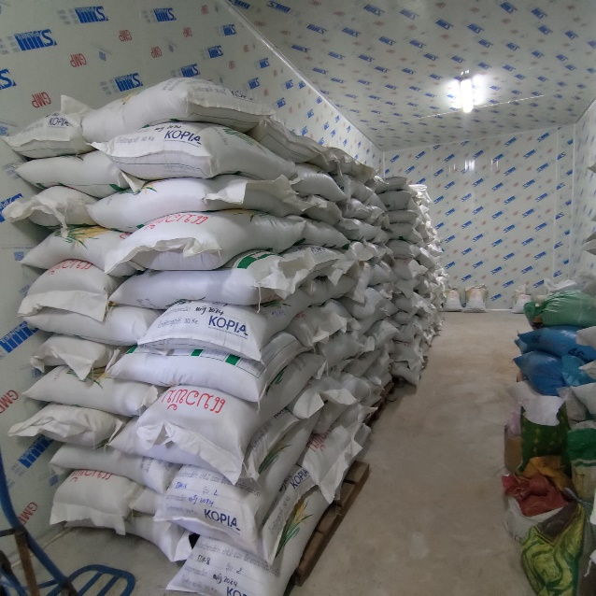 | 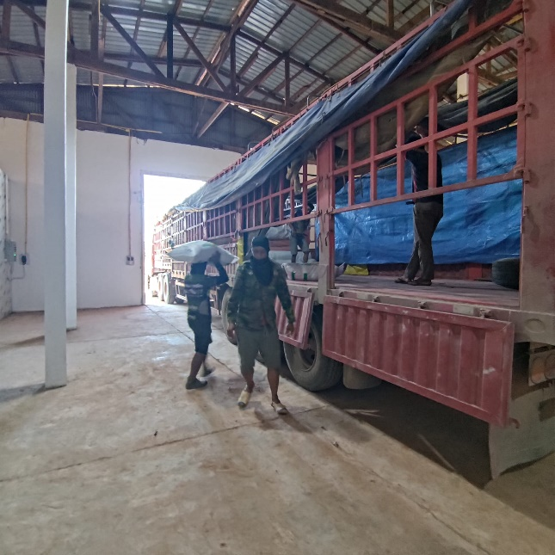
Figure 1: Agricultural Inputs in store for distribution in Luang Namtha Province

- Highlights of the FARM Programme in 2024

A Note from the Programme Manager
As a reflection on the achievements of 2024, significant progress had been made by the FARM Project in Lao PDR. The year was marked as pivotal, with a solid foundation laid for promoting sustainable agricultural practices and reducing the risks associated with hazardous agrochemicals. Collaboration, capacity-building, and notable advancements were prioritized in efforts to strengthen a sustainable agricultural sector.

The project's inception meeting in May and its official launch in August,2024 , set ground for successful project implementation. The events ensured inclusive participation of stakeholders, clarified roles, and promote shared vision for the project success. Progress was made across various components, driven by the collective commitment and collaboration of stakeholders involved. Progress was made across various components accelerated by the collective commitment.

One of the key achievements was the strengthening of legal frameworks. Drafting of the law on sustainable agriculture was advanced, alongside the initiation of consultations on the decree on fertilizers, which aligned with the national priorities. The measures are aimed at improving governance of agricultural inputs and support sustainable farming practices.
Capacity-building was central to the project's work. A notable milestone included the training of 47 technical staff in Xiengkhouang Province on regulating agrochemical trade. Local authorities were equipped with the skills necessary to enforce regulations effectively and promote best agricultural practices. Plans to expand the activities to other provinces are being developed to expand their impact.

Stakeholder engagement also saw significant progress. Workshops were held in Xiengkhouang and Oudomxay Provinces to align on pilot activities and encourage collaboration. The engagements brought together representatives from different government agencies and local authorities, ensuring inclusivity and alignment with the community needs.

Looking ahead to 2025, the focus will shift towards scaling up pilot programmes, advancing policy reforms, and enhancing public awareness campaigns to promote sustainable agricultural practices on a national scale. Efforts will aim to deliver tangible benefits to farmers and communities while contributing to environmental sustainability and improved livelihoods.

Gratitude to all partners, stakeholders, and the dedicated project team for their invaluable contributions. A sustainable and thriving agricultural future in Lao PDR is being shaped through these collective efforts, benefiting both people and the environment.

Highlights of FARM Programme launch in Lao PDR

The launch of the project took place on 15 May 2024, marked an important moment with the signing of the project document by Ms. Martine Therer, Resident Representative of UNDP Lao PDR and Mr. Bounchanh Kombounyashith, Director General of the Department of Agriculture (DOA) under the Ministry of Agriculture and Forestry (MAF). The event was elevated by the presence of Mr. Kikeo Singnavong, Vice Minister of MAF and participation of key partners which provided an opportunity to reinforce the importance of collaboration to achieve the target objectives.

The project inception was instrumental in creating awareness about the project's objectives, framework, and implementation strategy among the stakeholders. The event provided stakeholders with insights on the roles, support mechanisms, and shared responsibilities among the UNDP Country Office (CO), the Project Management Unit (PMU) and other stakeholders. It was clarified that was to be implemented through the National Implementation Modality (NIM) with Country Office supports ensured clarity in the implementation process.

The key discussions during the meeting centered on the project's governance and operational framework. Stakeholders examined decision-making structures, roles, and functions; reporting and communication protocols; and mechanisms to address potential challenges. These measures aim to establish a transparent, accountable, and cooperative approach to achieving the project objectives.

The event's significance was further amplified by media coverage in the national newspaper, Vientiane Times, which highlighted the initiative's importance in promoting sustainable agricultural practices and addressing pressing issues in agrochemical management. For more details, please see the press release https://shorturl.at/OzfRd

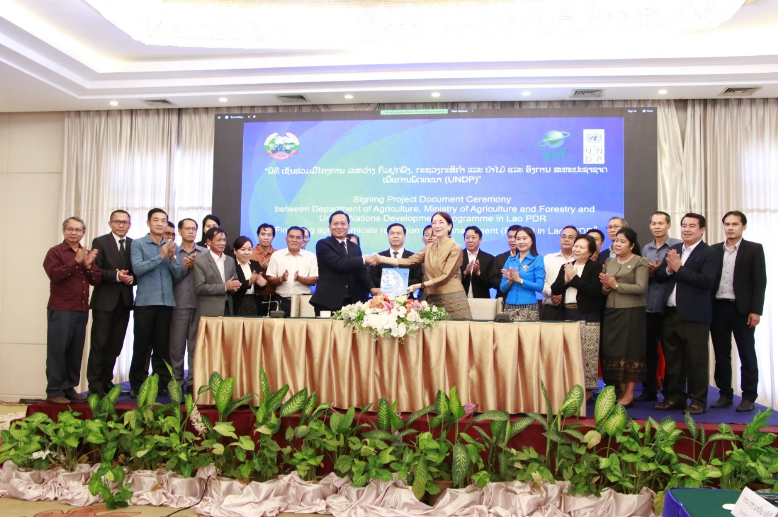

Figure1: Project inception meeting held on 10th May 2024 in Vientiane Capital, Lao PDR.

Child Project Inception Timeline
Project Duration: 60 months
LPAC Meeting: 29 December 2022
Start Date: 11 April 2024
Completion Date: 11 April 2029
Mid-Term Review Submission: 11 October 2026
Terminal Evaluation Submission: 11 January 2029
Operational Closure Date: 11 January 2030
Financial Closure Date: 11 July 2030

Finance and Investment Highlights

The Financing Agrochemicals Reduction and Management (FARM) project in Lao PDR allocated a total budget of USD 400,816 for 2024, with expenditures amounting to USD 142,670.02 (36%) and a remaining balance of USD 258,145.98 (64%). The financial investments have been distributed across five key components, which focus on strengthening regulatory frameworks, improving access to finance, promoting knowledge management, conducting monitoring and evaluation, and ensuring effective project management.

Strengthen Regulatory, Policy, and Investment Frameworks (Component 1) was allocated the largest share of USD 184,709 (46% of the annual budget). The component focuses on the development of institutional capacities, regulation and policies to enable sustainable agrochemical reduction use of hazardous chemicals. Expenditures stand at USD 74,904.09 (41%).

Improve Access to Finance Aligned with Sustainable Alternatives (Component 2) was assigned USD 91,600 (23% of the annual budget). The component promotes access to financial resources for adopting sustainable agricultural practices that raise incomes. By the time of reporting, expenditure of USD 13,657.29 (15%) of the budget had been utilized.

Effective Knowledge Management Platforms and Capacities Built in agrochemical waste management and disposal methods (Component 3) had a budget of USD 46,495 (12% of the annual budget). A total expenditure of USD 3,193.38 (7%), had been utilized under the component which focuses on the development of knowledge-sharing platforms and capacity-building programs to support safe agrochemical waste management practices.

Monitoring and Evaluation (Component 4) was allocated USD 32,000 (8% of the budget), with expenditures of USD 14,531.96 (45%). The component focuses on project accountability and progress tracking through regular monitoring and evaluation activities. Training and travel costs have been effectively utilized to support the development of an M&E framework.

The Project Management Costs was assigned a budget of USD 46,012 (11% of the total budget), a total of USD 36,259.56 (79%), has been utilized. The component focuses on operational coordination, contractual services, and information management to ensure the smooth implementation of the project.

Stakeholder Engagement and Partnerships (1 page)
Key events
National consultation workshop was held on Draft Decree on Clean Agriculture (sustainable agriculture) was held on 6th November 2024 at Landmark hotel in Vientiane Capital. The workshop organized under the leadership of the Department of Agriculture (DOA), Ministry of Agriculture and Forestry (MAF), brought together 33 participants (5-Female) including senior officials and technical staff from Ministry of Agriculture and forestry (MAF), Ministry of Justice (MoJ), and the Prime Minister Office (PMO). The objective of the workshop was to validate the draft decree, collect feedback from stakeholders, gather stakeholder feedback, and ensure alignment with national laws and regulatory frameworks. Furthermore, the consultation ensured that the decree did not conflict with the existing national legislation.
Co-financing Updates

Co-funding source | Type | Total ($) | Funds disbursed | %  disbursed | Remaining ($)
IFAD | Grant | 6,000,000 | 660,000 | 11% | 5,340,000
Korean Government | Grant | 3,300,000 | 2,750,000 | 83% | 550,000
World Bank | Grant | 2,000,000 | 1,600,000 | 80% | 400,000
GEF | In kind | 200,000 | 200,000 | 100% | 0
Government | In kind | 1,000,000 | 100,000 | 10% | 900,000
Government | Grant | 7,900,000 | 820,000 | 10.4 | 7,080,000
 |  | 20,400,000 | 6,130,000 | 30% | 14,270,000

Summary of key field activities in 2024

Activity | Location | Date | Participants | Female | Highlights
Stakeholders’ Engagement Workshop | Xiengkhouang Province | 15-16 August 2024 | 62 | 20 | Provincial and district-level stakeholders were engaged (department of agriculture, environment,environment police, customs) to plan pilot activities.
Stakeholders’ Engagement Workshop | Oudomxay Province | 11-12 September 2024 | 41 | 8 | Collaboration across Bokeo, Luang Namtha, and Oudomxay provinces with a focus on inter-agency cooperation.
Training on Agrochemical Trade Regulation | Xiengkhouang Province | 3-5 September 2024 | 47 | 22 | Capacity building of stakeholders to regulate hazardous agrochemical trade effectively.
Trainings on Agrochemical Trade Regulation | Oudomxay Province | 3-5 December 2024 | 43 | 8 | Strengthened regional cooperation and harmonized approaches to avert illegal imports and trade of hazardous agrochemicals.
Trainings on Agrochemical Trade Regulation | Bokeo Province | 9-11 December 2024 | 38 | 8 | Strengthened regional cooperation and harmonized approaches to avert illegal imports and trade of hazardous agrochemicals.

- FARM Child Projects: 2024 Updates and 2025 Milestones ( Please follow the template)
- Child Project Update (1 page per country)
  - Project Team Updates

    - Team composition with photo and quotes
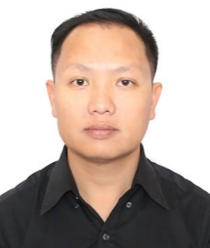  Mr. Thanongkham Venethongkham  Project Coordinator | "Though the project is still in the early phase in Lao PDR, it has already demonstrated promising progress. The engagement of stakeholder and local communities highlight the power of inclusive approach in achieving the target objectives. Capacity building and collaboration will be key pillars to achieve the project objectives."  Mr. Thanongkham Venethongkham
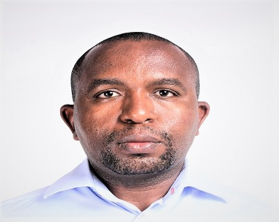  Mr. Bernard Bett  M&E and Reporting Specialist | “The progress made is encouraging and impactful. Establishing a strong foundation through consistent monitoring and active community engagement has been critical to the progress ensuring alignment with the needs." – Bernard Bett
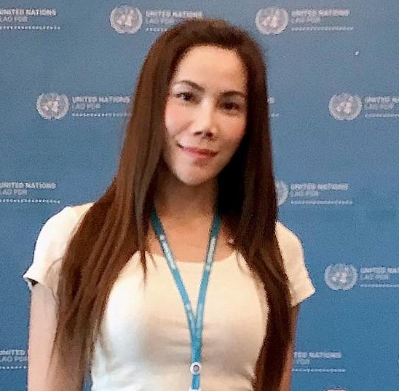  Ms. Minsa Sorthipmany  Finance and Administrative Officer | “The progress achieved through the Project reflects the dedication of the team and commitment of stakeholders. Through efficient financial management and collaborative efforts, we are not only going to attain the target results but also set the foundation for sustainable agricultural practices that benefit our communities." – Minsa Sorthipmany
Technical specialist | Under recruitment

The project inception
The project inception held on 15 May 2024, co-chaired by the Director General of the Department of Agriculture, Ministry of Agriculture and Forestry and the resident representative, UNDP Lao PDR. The inception workshop, attended by 52 participants(16-Female) provided an opportunity for the stakeholders on the overview of the project, objectives, outcomes, multiyear- work plan, the total budget and implementation arrangements as well as the responsibilities of the various stakeholders. Participants from government agencies, international development partners, and NGOs attended the workshop, which allowed them to provide input and identify the areas of collaboration during planning phase and contribute towards achieving the target results.

Field visit highlights, press release weblinks, and high-resolution photos

During the reporting period, capacity building training was undertaken designed to enhance capacity of technical staff responsible for agrochemical management, empowering them to enforce regulations effectively, ensuring that the province safeguard public health, the environment, and the integrity of its agricultural practices.

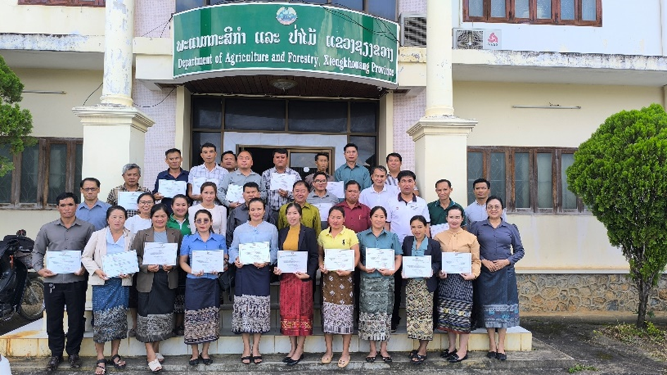
Figure 2: participants of training on agrochemical trade regulation held in Xiengkhouang Province

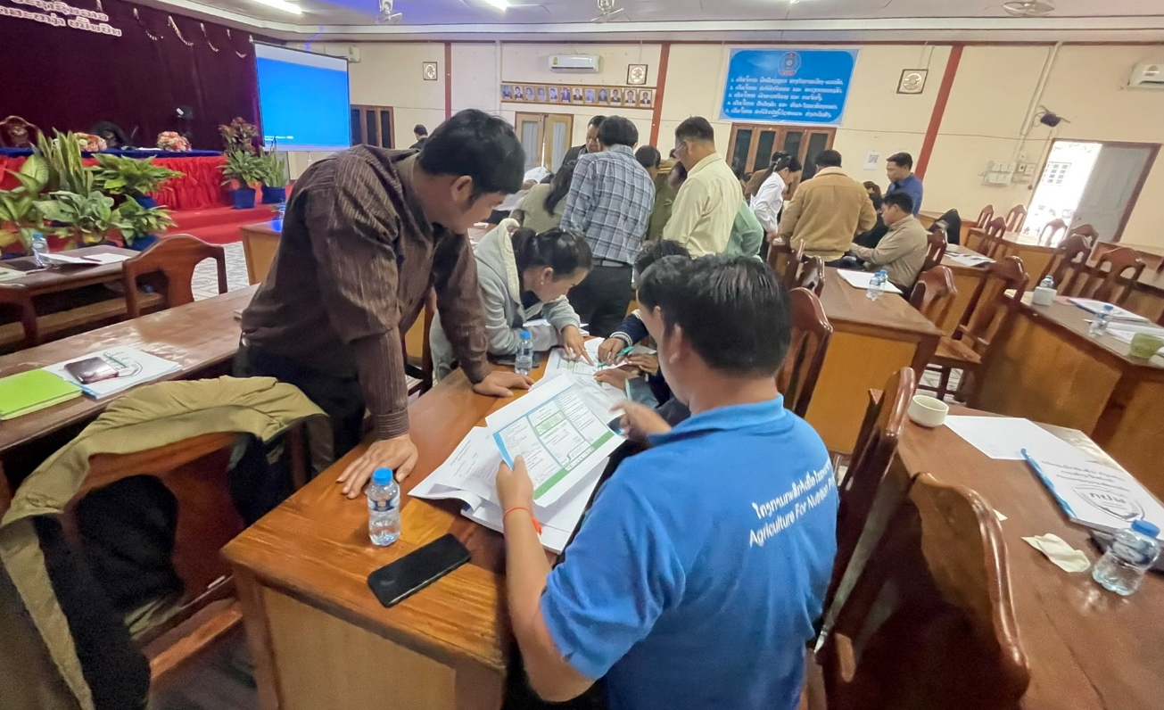
Figure 3: Participants of capacity building training held in Oudomxay province(3-5 Dec,2024)

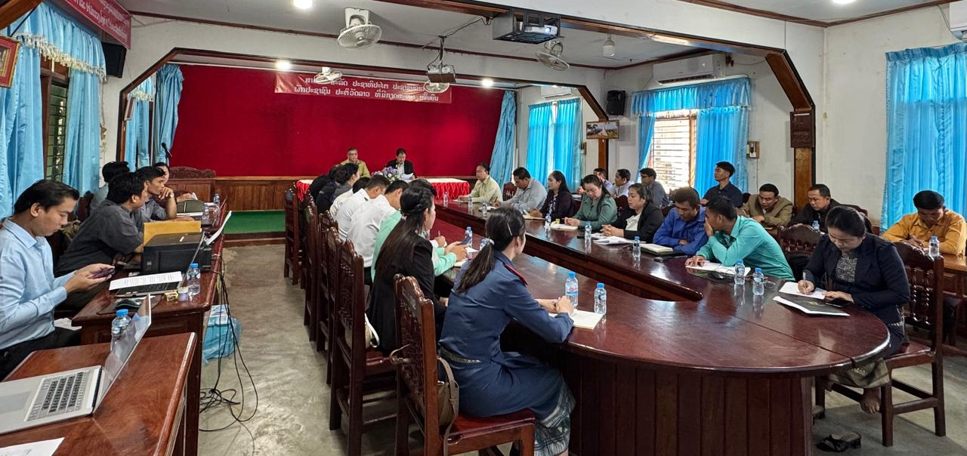

Figure 3: Participants of capacity building training held in Bokeo province (9-11 Dec,2024)

Component-wise Updates (with data where possible)
Policy and Enforcement
The Decree on Fertilizers on initial phase with the recruitment of the legal expert on the final stages. The decree will establish a regulatory framework for fertilizer production, import, distribution, and use. Additionally, on 6 November 2024, stakeholder engagement workshop was attended by 33 participants(5-Female), provided an opportunity to validate the draft decree, collect feedback from stakeholders, gather stakeholder feedback, and ensure alignment with national laws and regulatory frameworks. Furthermore, the consultation ensured that the decree did not conflict with the existing national legislation. held to validate the draft Decree on Clean Agriculture, incorporating feedback from relevant stakeholders.

Finance and Investment
The project office was operationalized, which enhanced operational effectiveness and the ability to interact with national partners involved in the component, particularly the financial institutions. Initial engagement has been started to explore on the existing financial products, assistance for agricultural finance access, the initiative has started looking into possible collaborations with banks and other important parties.

Value chains and public demand
The FARM Project in Lao PDR gained visibility through diverse communication platforms, including a featured article in the national newspaper-The Vientiane Times , highlighted the project efforts to reduce hazardous pesticide use, promoting safer agriculture and improved environmental health. Additionally, the project's updates and achievements were actively shared on social media, with two engaging Facebook posts showcasing activities and visuals that resonated with the community. The efforts effectively expanded the project's outreach, emphasizing the positive impact of sustainable agricultural practices on both the environment and local livelihoods.

Stakeholder Engagement
During the reporting period, stakeholders engaged included the Ministry of Finance, Ministry of Health, Ministry of Natural Resources and Environment, the EU, FAO, Helvetas, UNEP, SAEDA, the Asian Development Bank, and the Provincial and District Agriculture and Forestry Offices in the target provinces. A UN-to-UN Agreement on the final stages between UNDP and FAO to support the implementation of the project activities particularly under regulatory and policy frameworks. The collaboration will leverage the strengths and expertise of both agencies to enhance project outcomes.

Expectations for 2025
In 2025, the project will prioritise scaling up pilot programmes to promote sustainable agricultural practices, targeting to reduce reliance on harmful agrochemicals. It will also support enhanced capacity of provincial authorities to the challenge of illegal trade of banned agrochemicals through strengthened partnership with local authorities.

At the national level, work on legal frameworks will continue with the aim of enhancing regulations and policies that contribute to reducing use of hazardous chemicals. Public awareness campaigns will be upscaled to reach more farmers and stakeholders, to create awareness on the safe and sustainable use of agrochemicals, encouraging behavioral change. The project will also work closely with the financial institutions to increase opportunities to support financial access and availability of alternative products which are environmentally friendly in agricultural production.

- FARM Programme Progress 2024
Governance and Internal Coordination
Programme Advisory Group (PAG) and Project Steering Committee (PSC) updates
Regular weekly meetings were conducted between UNDP and project management unit provided oversight and guidance for project implementation in alignment with FARM objectives.
Project Steering Committee meeting was held on 20-21 August 2024 which involved officials from Vientiane Capital and Xiengkhouang Province took place in Xiengkhouang Province on, focused on project progress, approval of target activities and strategies to enhance cross-province collaboration, ensuring effective stakeholder engagement.

Working Groups: KM&COM Coordination Group, Project Managers' Calls, PRB Pollution Working Group
KM & COM Coordination Group
The project focal point took part in knowledge management and communication group which aid streamline knowledge management and communication strategies to enhance information dissemination and stakeholder engagement.

Project Managers' Calls

The project focal point participated in monthly project manager`s call, providing a opportunity to share progress updates, address challenges, and exchange best practices with other participants in other countries. The calls enhanced coordination and facilitated effective implementation by learning from others on how to address the challenges in similar context.

Matchmaking and Synergies

In Lao PDR, the FARM project has initiated interlinkages among child projects to ensure alignment with global FARM goals, promoting a cohesive approach to sustainable agricultural practices. The objective to enhance knowledge sharing and capacity building across regions, leveraging global knowledge to strengthen local implementation. Initial steps have been taken toward collaboration between Lao PDR and Vietnam, marking the beginning of engagement aimed at having cross-border cooperation to address shared challenges and opportunities in sustainable development.

Progress by Key Areas
Policy and Enforcement
- National consultation on policy strengthening initiated, focusing on integrating sustainable practices.
- Capacity building enhanced to support enforcement in collaboration with local authorities.
Identification of knowledge needs (based on inception reports)
- Enforcement capacity to control the trade of illegal agricultural chemical products
- Lack of legal framework for agricultural chemicals

Finance and Investment
- Engagement with financial institutions to explore on innovative financing mechanisms targeting smallholder farmers have been initiated
Identification of knowledge needs (based on inception reports)
- Limited financial products tailored for smallholder farmers

Capacity Building and Knowledge Sharing
- Awareness about the use of hazardous chemicals shared through social media platforms to connect with the stakeholders.
Identification of knowledge needs (based on inception reports)
- Limited awareness by the chemical users which need increased awareness

Partnerships and Stakeholder Engagement

Strategic vision and objectives for stakeholder engagement (from pro-doc)

The FARM Project in Lao PDR embrace a participatory approach to stakeholder engagement, underscoring inclusion, transparency and collaboration to achieve the project objectives. Targeting to strengthen partnerships among central and local authorities, NGOs, and communities while leveraging on a multi-stakeholder governance framework to ensure broad representation and effective decision-making. The project also prioritizes community engagement through tailored communication methods and a grievance redress mechanism, promoting trust and safeguarding all voices be heard in the development process.

Value Chain Approach and Engagement Channels

The FARM Project in Lao PDR employs a value chain approach to enhance the efficiency and sustainability of agricultural livelihoods. It promotes sustainable agricultural practices and resilient livelihood activities, integrating local markets through targeted capacity building and market analyses. By piloting innovative financial products and alternative products to hazardous agricultural chemicals, the project enhances community participation and awareness in sustainable practices, promoting inclusive development and environmental conservation.

Results

Partnership with over 15 partners in Lao PDR has been initiated, the partners identified includes NGOs, academic institutions, and private sector entities, to promote collaboration and leverage diverse expertise in the project implementation.

Strategic vision and objectives for COM and KM (from pro-doc)
The project integrates a t Communication and Knowledge Management (C&KM) strategy aiming to enhance the sharing of lessons learned for scaling project outcomes. It promotes transparency and accountability through monitoring and reporting and promotes adaptive management by integrating timely feedback. The approach ensures that insights are effectively disseminated and that the project remains responsive to the needs of the communities it serves.

C&KM Coordination Group
The FARM Project in Lao PDR regularly engage in C&KM Coordination Group ensures the seamless implementation of activities by aligning them with the project's objectives and promote effective coordination among stakeholders. The group brings together efforts of diverse stakeholders to create a collaborative framework. By enabling transparent and efficient communication, the group encourages learning across the teams important in supporting the delivery of project results and transformation of livelihoods.

Results

Green Forum FARM Group
The FARM project In Lao PDR participates in the activities of the Green Forum FARM Group, created to engage diverse stakeholders, promoting collaboration and learning. The platform encourages active participation, allowing stakeholders to share experiences, discuss challenges, and contribute to collective problem-solving.

Programme Monitoring and Evaluation Framework (inputs from CABI)

Framework Design
The FARM Project in Lao PDR has a Monitoring and Evaluation (M&E) framework to systematically track progress, assess outcomes, and identify areas for improvement. The framework serves as a tool to ensure accountability, measure the effectiveness of interventions, and inform adaptive management strategies across the project’s components.

Data Collection Tools
Standardized data collection tools have been implemented to ensure consistency and reliability in gathering information across the various projects under the FARM initiative. The tools are designed to capture quantitative and qualitative data, enabling detailed analysis of project performance and alignment with strategic objectives.
Results
Key achievements over the period includes strengthened institutional capabilities and progress made on strengthening regulations governing trade of fertilizer. However, the evaluations also identified areas requiring further attention, particularly in enhancing stakeholder engagement and enhancing public awareness on the dangers of hazardous chemicals to communities and ecosystems.

5. Looking Ahead
Strategic outlook for 2025

In 2025, the project will prioritize advancing sustainable agricultural practices through strategic interventions that align with the needs and national priorities. Key focus will be strengthening policy and regulatory frameworks, addressing gaps in existing policies and regulation frameworks, the project aims to create an enabling environment for sustainable practices and promote viable alternatives to hazardous chemicals in agricultural production.

Building local capacity and promoting stakeholder engagement will remain vital to achieving the project objectives. Targeted training, workshops and collaboration programs will be utilized to empower stakeholder involved in regulation development, enforcement of regulation, community leaders and other stakeholders involved in the implementation of project theme in the target regions. The inclusive approach is designed to ensure enhanced ownership and aid scaling up of project outcomes.

Another critical area of focus will be improving access to financing mechanisms to support sustainable agricultural practices and reduction of hazardous chemicals at the farm level. The project will support innovative financial models that will enable access to financial resources for smallholder farmers and local agricultural actors. The objective will be achieved by partnering with financial institutions and leveraging public-private partnerships, the program aims to mobilize resources and incentivize the adoption of sustainable agricultural practices and promotion of alternative pesticides. Financial access t will be vital in empowering farmers to transition to sustainable practices without affecting their economic stability.

The program will also prioritize communication and awareness campaigns targeting diverse stakeholders. The efforts employ different communication strategies to disseminate information on the existence and benefits of alternative pesticides, sustainable agricultural practices and the avenues to access finances to implement their sustainable agricultural activities. The campaign messages will be localized and ensure that they are culturally sensitive ensuring they resonate with the audiences, promoting adoption and behavioral change.

The project will monitor the progress of the project interventions to ensure that all the activities are within the project results and data collected are used to guide decision-making, identify implementation challenges, and track the impact of interventions across all project components. The use of the evidence based decision making will be vital to ensuring that the interventions achieve the target outcomes through adaptive measures to the challenges faces throughout the intervention period.

